Microsoft Word Resources Add In

ECE 4318.01 Software Engineering

Group 1 – Design

Group Leader

Michael Hicks

Members

Sam Bennett, William Lai, Isaac Elizarraz, Michael Bishara, Newton Le

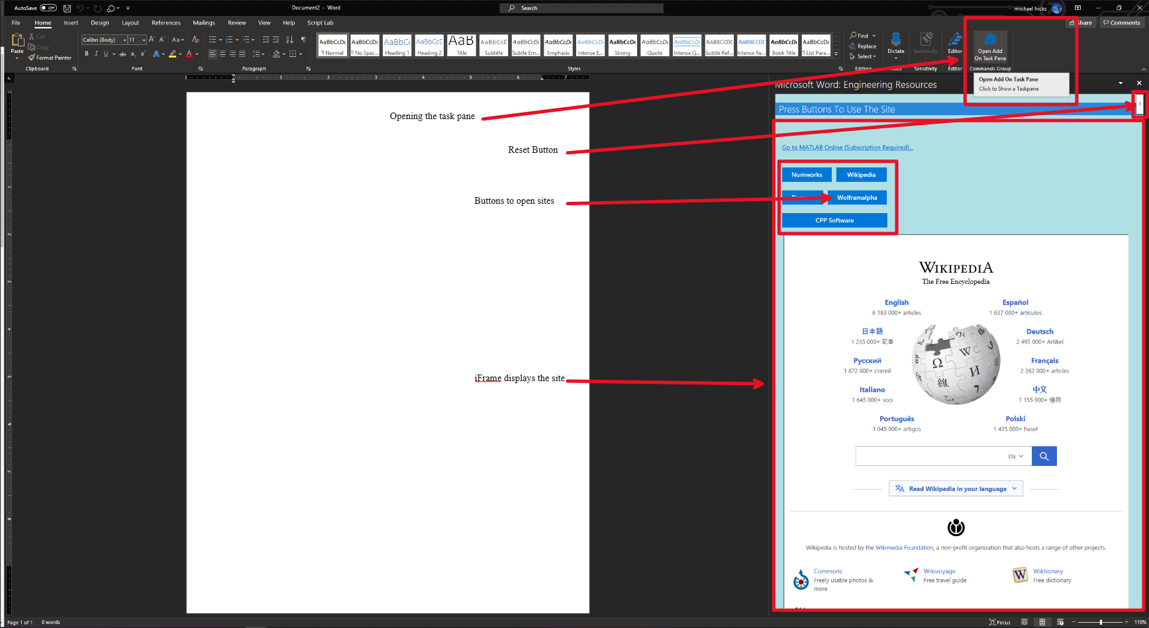

The design for this was straight forward. We utilized the Microsoft/Sharepoint workspace in visual studios to create this project.

We started by creating a simple template of the project and understanding how HTML and JavaScript worked together. We then made a list of functions and requirements for our project. This helped us work through the code and add each requirement in one at a time.

The Design needed the following:

1. Site Navigation with buttons
2. MATLAB Link to online MATLAB
3. iFrame embedded sites
4. Be able to attach to Microsoft word api

We had more in mind for it but Microsoft being who they are denied every attempt due to security reasons and us not being a real company. The school also denied us to use them as one. So, the design changed and shrank through the weeks we worked on it due to this problem.

